Log in



Log out



Create



Edit

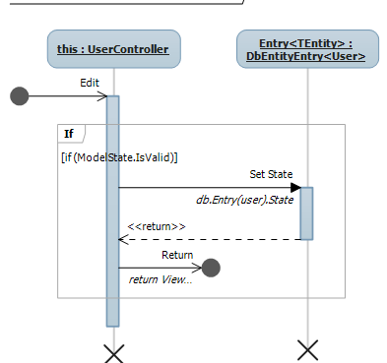

delete

get user

